Part 1: Hugging face

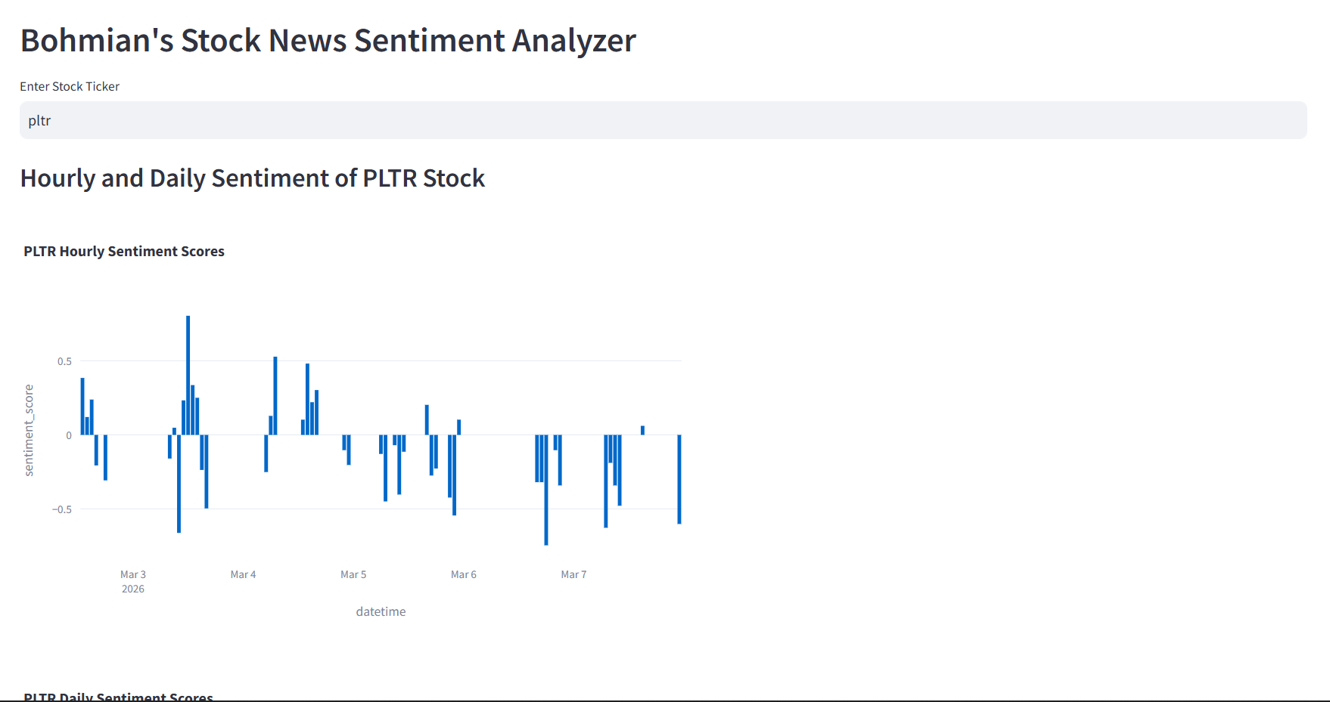

Part 2: Kaggle

Link: https://www.kaggle.com/datasets/amirmotefaker/stock-market-analysis-data
I want to build a stock market prediction AI that would read through the data, understand the way the market moves, and predict the future of the stock market.

Part 3: Google Colab
